First version: 2012-10-17

“Distributed feedback semiconductor lasers”, John Carroll, 1998

The slab waveguide is described on page 81-95, p313-323.

# TE mode

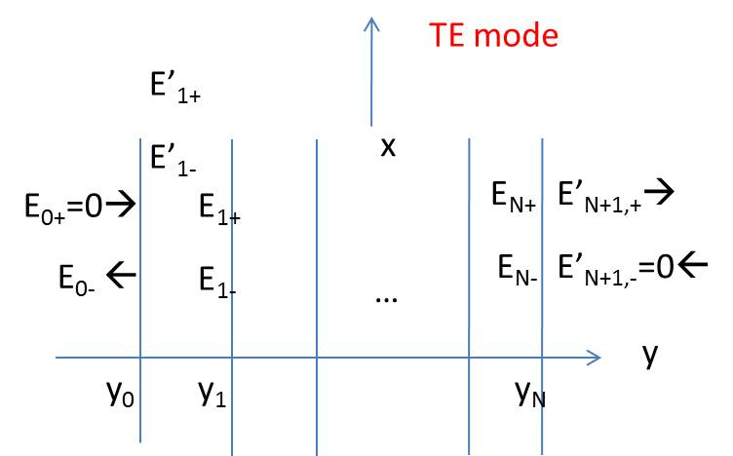





continuity condition: tangential of E and H, i.e., (Ex, Hz)







…

 (1-9)

The expression for the last layer should be paid care due to the absence of d.

 (1-10)

 (1-11)



# TM mode









It is only the total E fields that indicate the strength of the interaction with the electronic gain along the guide.



# Far fields

Fourier transform of the near field: 

Due to Huygens effect, we should include obliquity factor: 

is the reflection coefficient for TE mode, n is effective index.







## JAP,44,5470(1973)

GaAs/AlGaAs DH lasers



Phenomena:

1, calculated value larger than experimental

2, experimental value decrease more rapidly than calculated

Explanation:

1, refractive index contrast may be smaller;

2, boundary condition may be different between theory and practical

## JAP,46,2323(1975)



Huigens effect shrinkage the divergence